Invitation & application guidelines
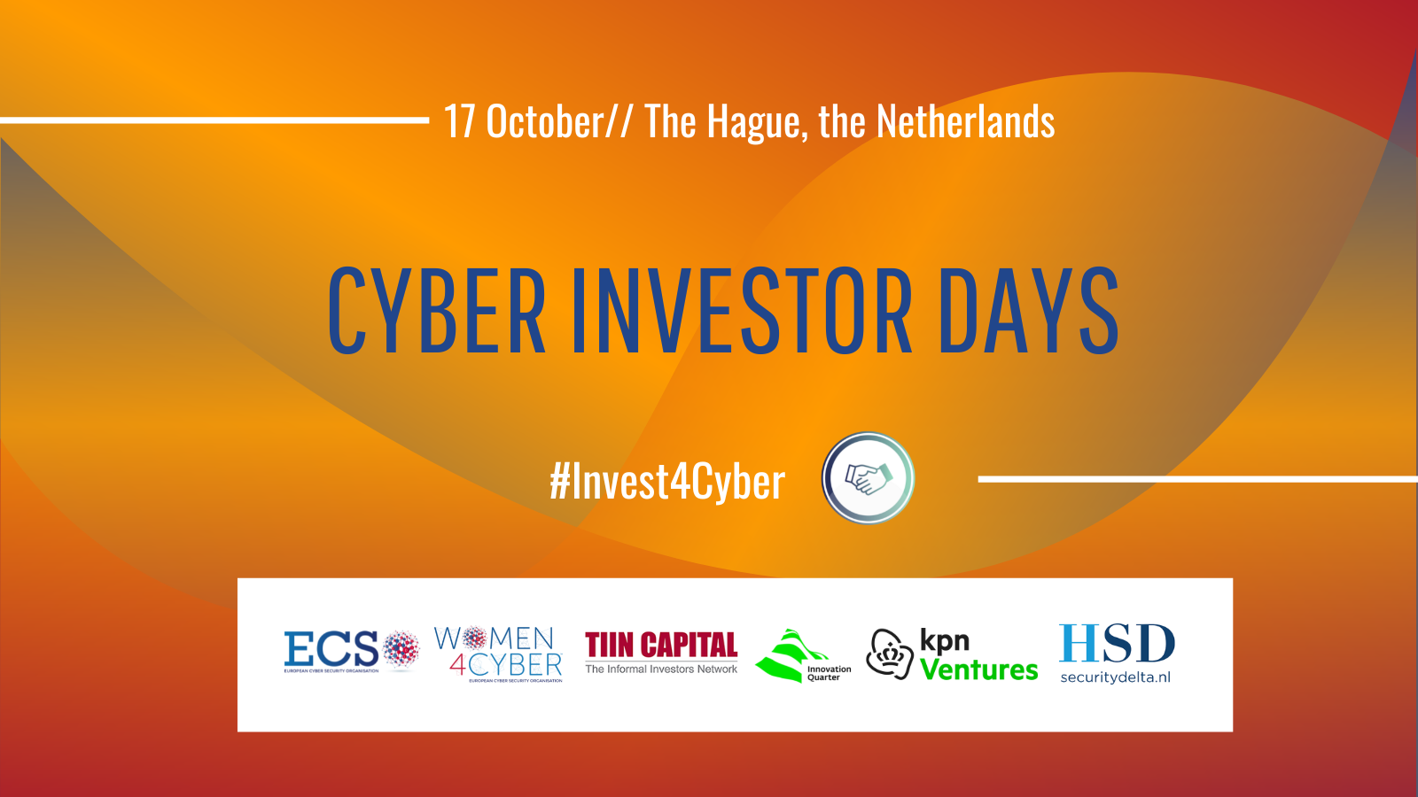
Don't miss your chance to meet with fellow cybersecurity entrepreneurs and industry leaders and attend the pitches & B2B meetings
TIIN Capital together with ECSO, InnovationQuarter, KPN Ventures and Security Delta (HSD) have the pleasure of inviting you to the Dutch edition of the ECSO Cyber Investor Days, scheduled on the 17th of October in The Hague, the Netherlands.
The most promising European cybersecurity start-ups and scale-ups will have a chance to pitch their innovative cybersecurity solutions and hold B2B meetings with the leading investors and corporates from around Europe. The Dutch edition of the Cyber Investor Days will be organised as a side event of the ONE Conference and will take place in-person.

SUBMISSION DEADLINE: 14 September (Wednesday)

ECSO cybersecurity business matchmaking events are designed to:
- Cover different investment phases, ranging from seed to strategic investment and M&A,
- Give exposure to potential corporate customers and business partners.

ECSO STARtup Award 2022. The two best cybersecurity companies participating in the Dutch edition of the ECSO Cyber Investor Days will be nominated to compete for the ECSO’s European Cybersecurity STARtup Award 2022. Nominees will be selected by the local jury and will be invited to participate in the final competition, which will be held in March 2023. During the final ceremony, nominees will pitch to the European jury and will have a unique opportunity to present themselves to high-level investors, corporate executives and cybersecurity experts. For more information, click here.

The launch of the Women4Cyber STARtup Award. ECSO and the Women4Cyber Foundation have joined forces to give recognition to the cybersecurity companies founded or co-founded by women and/or to the companies with at least 50% female employees. The Women4Cyber STARtup Award will be given to the female-led company, selected by the jury for the ECSO’s Cyber Investor Days and ECSO’s Cybersecurity STARtup Award.

See the ‘Application Roadmap’ on the following page. Good luck with your submission!

APPLICATION ROADMAP
The selection of the participating start-ups and scale-ups is based on the most innovative solutions to be presented to investors and corporates

About the organisers

European Cyber Security Organisation (ECSO)
European Cyber Security Organisation (ECSO) is a not-for-profit organisation, established in 2016. ECSO unites more than 270 European cybersecurity stakeholders, including large companies, SMEs and start-ups, investors, research centres, universities, end-users, operators, associations, as well as regional and national administrations. ECSO works with its members and partners to develop a competitive European cybersecurity ecosystem providing trusted cybersecurity solutions and advancing Europe’s cybersecurity posture and its technological independence: www.ecs-org.eu

Women4Cyber Foundation
The Women4Cyber Foundation is a non-profit organisation founded in 2019 aimed at promoting, encouraging, and supporting the participation of women in the field of cybersecurity. Its mission is to develop and grow a cybersecurity community through networking, awareness, education, and training. To do that, the Foundation works to help raise the voices of women through social media and events, enhance female participation in cyber education, promote Role Models and tailored training programmes for entry, up-skilling or re-skilling in cybersecurity: www.women4cyber.eu

TIIN Capital
TIIN Capital is a venture capital firm formed by a strong combination of angel investors, family offices, governmental bodies, and corporates. Founded in 1998, TIIN Capital invests in technology companies through several funds and launched its 6th Venture Capital Fund in 2018: the Dutch Security TechFund. With this fund we focus on early to growth stage companies, active in Cybersecurity and Security solutions. Our purpose is to help passionate people build great companies. Partnering with TIIN Capital means joining an empowering network of business leaders, entrepreneurs, techies and potential partners. For more information see: www.tiincapital.nl
InnovationQuarter
InnovationQuarter is the regional economic development agency for the Province of Zuid-Holland, also known as the Greater Rotterdam-The Hague area, which includes Leiden and Delft. It invests in innovative, fast-growing local enterprises from its four funds and helps foreign companies become established in this unique delta region. Our experienced team assists foreign companies free of charge in every step of the international expansion process; from first inquiry to growing the business in the Greater Rotterdam-The Hague area. InnovationQuarter also facilitates national and international collaboration between forward-thinking entrepreneurs, knowledge institutes and governments. By collaborating with the business community, the agency is helping to make this region one of the most innovative regions in Europe. For more information see: www.innovationquarter.nl
KPN Ventures
KPN Ventures is the investment arm of KPN. KPN has been the leading provider of telecommunications and IT services in the Netherlands for almost 140 years. KPN Ventures focuses on direct and fund-in-fund investments in innovative and fast-growing European technology companies in various Telco-related themes, including Network technology, Cyber ​​Security, Internet of Things, Digital Healthcare, Remote Working etc. For more information see: www.kpnventures.com
Security Delta (HSD)
Security Delta (HSD) is the Dutch security cluster. Over 275 companies, governmental organisations and knowledge institutions have been working together since 2013 to make a difference in securing our digitising society. They share their knowledge and collaborate on innovative security solutions, which can be scaled within the Netherlands and internationally. HSD 'thinks, dares and acts'. By providing access to knowledge, innovation, market, finance, and talent, HSD takes care of the preconditions for a successful security cluster. The HSD Campus in The Hague is the cluster’s inspiring meeting place. We do this with the common goal of strengthening the Dutch economy, increasing employment rates and making the Netherlands more digitally resilient. For more information see: www.securitydelta.nl

