Start-ups & scale-ups application form

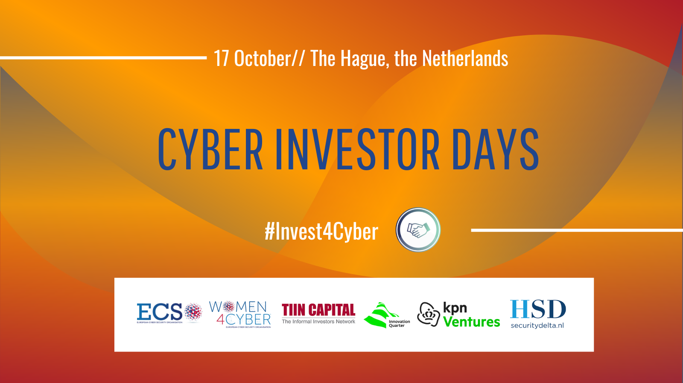
ECSO CYBER INVESTOR DAYS
17 October // The Hague, the Netherlands
Don't miss your chance to meet with fellow cybersecurity entrepreneurs and industry leaders and attend the pitch event & B2B meetings

European cybersecurity start-ups and scale-ups are invited to provide their company’s profile and indicate whether they are looking for access-to-finance opportunities (B2B meetings with potential investors). Companies seeking access-to-market opportunities (B2B meetings with potential customers and partners, i.e. integrators, corporates etc) are also invited to apply.

IMPORTANT: The duly filled application form (pdf) and the 5-7 slides pitch deck (pdf, 1 MB size) shall be submitted via the official registration website (link).
DEADLINE: 14 September (Wednesday)

ADVICE: Keep your application convincing and concise. Respect the indicated character limit.

[Insert company’s name] | [Insert company’s logo]

WOMEN4CYBER STARTUP AWARD

ECSO and the Women4Cyber Foundation have joined forces to give recognition to the cybersecurity companies founded or co-founded by women and/or to the companies with at least 50% female employees.

The Women4Cyber STARtup Award will be given to the female-led company, selected by the jury for the ECSO’s Cyber Investor Days and ECSO’s Cybersecurity STARtup Award*.

If your company has been founded or co-founded by a female entrepreneur and/or more than a half of your company’s staff is female, and you would like to be considered for the Award, please indicate so below and provide the name(s) of your (co)-founder(s) and the composition of your team.
*To be considered for this Award, the company’s pitch will have to be delivered by a female representative.
I would like to be considered for the Women4Cyber Start-Up Award: YES / NO

[insert a short description of your company, including the names of your (co-)founders and team]

COMPANY PROFILE | CONTACT DETAILS
Market Segment: to be identified in the table below  Product Launch: [insert]  Employees: [insert]  HQ Address: [insert]  Website: [insert] | Name, Surname: [insert]  Email: [insert]  Phone: [insert]  +1 representative (name, surname, email): [insert]
YOUR INVESTORS
[please list them down here]

YOUR BOARD (CEO, Founder, CTO etc):
[please list them down here]

UNIQUE VALUE PROPOSITION – Problem, Solution, Product
Target Audience / Customer | [insert]
Statement of Need & Opportunity | [insert]
Product / Service Name | [insert]
Key benefits / Problem-solving capacity | [insert]
Primary Competitive Alternative | [insert]
Statement of Primary Differentiation | [insert]
MARKET & GO-TO-MARKET STRATEGY – 400 characters max
(Channels, geographies, segment priorities)
[insert, 400 characters max]

BUSINESS MODEL & USE OF PROCEEDS – 400 characters max
(Non-recurring vs. recurring; please quantify your use of proceeds – how much € & for what)
[insert, 400 characters max]

COMPETITION ON THE MARKET – 400 characters max
(Names & countries of your Top 5 contenders for the same customer budgets)
[insert, 400 characters max]

TEAM SIZE AND TEAM VISION – 400 characters max
(Relevant & well-rounded experiences, industry-specific skills, clear roles, notable advisors)
[insert, 400 characters max]

COMPANY COMPETITIVENES: TOP 3 ADVANTAGES – 400 characters max
(P.S. ‘we have the best team’ will not count as a competitive advantage – it must be systematic advantages)
[insert, 400 characters max]

FINANCIAL INFORMATION
Current Stage: [insert]
Previous Capital: [insert]
Monthly Burn Rate: [insert]
Capital Seeking: (does not apply for access-to-market opportunities): [insert]

ANNUAL FINANCIAL OVERVIEW & PROJECTION (in thousand euros, €)
Financial Year | 2020 | 2021 | 2022 | 2023 | 2024
Revenues
Expenditure
Net profit

MARKET SEGMENT
(Mark the capabilities and categories that your company meets)
Capability | Solution Category | Company’s market segment
IDENTIFY | Asset Mangement
 | Business Environment
 | Governance & Risk Management
 | Risk Assessment
 | Risk Management Strategy
 | Supply Chain Risk Management
PROTECT | Identity Management & Access Control
 | Awareness and Training
 | Data Security
 | Information Protection Processes and Procedures
 | Maintenance
 | Protective Technology
DETECT | Anomalies and Events
 | Security Continuous Monitoring
 | Detection Processes
RESPOND | Response Planning
 | Communications
 | Analysis
 | Mitigation
 | Improvements
RECOVER | Recovery Planning
 | Improvements
 | Communications

HOW DID YOU FIND OUT ABOUT THE EVENT?
(Please indicate how you learned about this edition of the ECSO Cyber Investor Days)
[comment here]

Thank you for you submission! You will hear back from us asap.

